**Highlights:**

* The implementation of an automated system successfully reduced fraudulent activity and enhanced operational effectiveness
* Accomplished a reduction in staffing requirements, leading to cost savings for the business
* Expedited processes by up to 80%, resulted in faster and more efficient operations
* Developed the system with a focus on user-friendliness and seamless integration into the existing workflow

**Mini Projects**

**Title: Twitter Scrapping**

Created a website that facilitated the scraping, downloading, and archiving of tweets; employed **Python** **scraping, data collection, MongoDB, and Streamlit** techniques for implementation.

**Title: Phonepe Pulse Data Visualization and Exploration**

Developed a webpage containing valuable insights and information about the data in PhonePe Pulse; utilized techniques such as **GitHub cloning, Python, Pandas, MySQL, MySQL-connector-Python, Streamlit, and Plotly** for implementation.

**Title: BisCardX: Extracting Business Card Data with OCR**

Created a webpage using **python** that enabled users to extract details from business cards using **OCR technology**; implemented a **Streamlit GUI** for user-friendly interaction. Utilized **SQL and data extraction techniques** to store and **retrieve the extracted information.**

**Title: E-commerce Sales Dashboard**

Developed a sales company dashboard for an e-commerce platform, displaying year-to-date sales information and generating valuable insights; implemented **Power BI and SQL Server Management** for data visualization and analysis purposes.

Certifications

* Master Data Science
* Google - Foundations: Data, Data, Everywhere
* Google - UX Professional Certificate (Tool-Figma)
* Digital Marketing Certification (SEO, Google Ads, Analytics)
* Photoshop Certification
* Power BI
* Artificial Intelligence and Machine Learning
* Complete Personal Development
* International Conference - Automated Survey System
* Engineer Yesterday, Today & Tomorrow

Extra Curricular

* Served as a fundraiser for Womenite NGO and received a certificate of appreciation and recommendation for my contributions
* Diploma in Fine arts
* Singing

**Personal Details**

* **DOB:** 5th April 2001
* **Languages Known:** English & Tamil

|  |  |
| --- | --- |
| C:\Users\snaks\AppData\Local\Microsoft\Windows\INetCache\IE\R383601Q\cell-phone-icon-7438-1024x1024[1].png +91 9894602680 | C:\Users\snaks\AppData\Local\Microsoft\Windows\INetCache\IE\ONJTNR4F\linkedIn_PNG4[1].png <https://www.linkedin.com/in/akshyashree> |
| C:\Users\snaks\AppData\Local\Microsoft\Windows\INetCache\IE\VOUCM46P\mono-mail-send-via[1].png snakshyashree5@gmail.com | C:\Users\snaks\AppData\Local\Microsoft\Windows\INetCache\IE\R383601Q\github_PNG47[1].png <https://github.com/Akshyashree> |

AKSHYASHREE S N

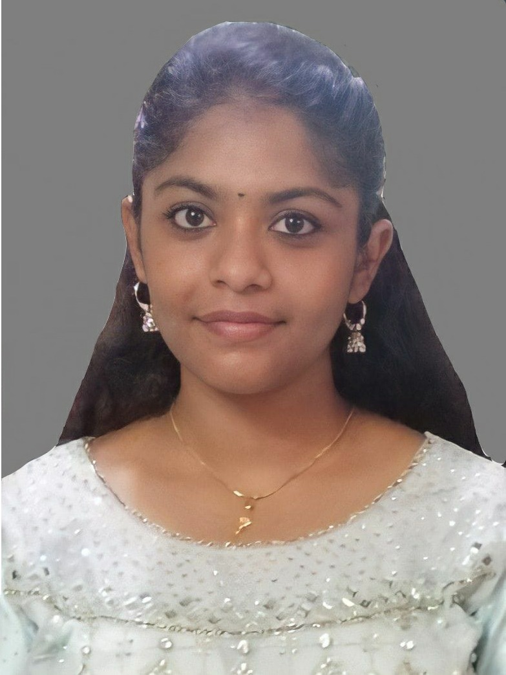

**Experience**

**Cognizant Technologies Feb’22-Present Program Analyst – IDE FSE .Net**

**Key Result Areas:**

TJC Modern CO

* Improving system efficiency and speed by resolving issues and eliminating unnecessary database references, resulting in smoother operations.
* Managing the updating of automatic email recipients' mail, reducing unnecessary correspondence and improving email effectiveness.
* Updating outdated stored processes with new ones, enhancing the system and optimizing operational efficiency.

Provider Portal

* Created the entire portal app using share point for the healthcare accounts to access the recent information across the accounts.

Mental Healthcare app

* Frontend UI enhancements and documentation of video call feature.

Med Assist

* Created a website for doctors for prescription automation with call transcription integrated with AI using Github Copilot.

**Highlights:**

* Played a key role in reducing user confusion and ensuring the secure transmission of accurate information, leading to increased user satisfaction and improved system confidence
* Reduced user misunderstanding and achieved 90% accuracy in information by resolving multiple issues and eliminated unnecessary database references
* Enhanced the system's effectiveness and performance through ongoing coding and debugging, leading to improved outcomes
* As the Scrum Master and team leader, facilitated effective collaboration and streamlined workflows, contributing to reduced user confusion, enhanced system security, and improved performance through ongoing coding and debugging efforts.

**Antares Weighing Feb’21- Jan’22  
Software Coordinator**

**Key Result Areas:**

* Developed a software automation that documented the weight of cargo vehicles, along with vehicle details, entry, and exit times
* Worked closely with the team to ensure the successful deployment and maintenance of the software automation
* Utilized Python programming skills to deliver a solution that met the firm's requirements & standards
* Automated a critical warehouse operation function, resulted in optimized processes

**Summary**

Experienced professional passionate about **Business Analytics, Data Analytics, and Software Development**. Skilled in translating business needs into technical solutions, utilizing **Python, C, C++, HTML, SQL, Angular**. Proficient in **statistical analysis, machine learning, and data visualization** with tools like **Power BI and Share Point**. Experienced in database management for efficient data handling.  
  
**Education**

* **Computer Science Engineering** (2022)

K. Ramakrishnan College of Engineering

**84.4%**

* **XII** (2018)

SBIOA Matriculation School

**73.17%**

* **X** (2016)

Chellammal Matriculation School

**87%**

Knowledge Preview

* Predictive Modelling
* Business Intelligence
* Data Analytics & Interpretation
* Project Management
* Data Visualization and Exploration
* Data Mining
* Requirement Gathering
* Documentation
* Process Improvement & Optimization
* Troubleshooting
* UI Designing

IT Skills

* Python
* Angular
* C
* C++
* HTML
* SQL
* Power BI